**DBMS ASSIGNMENT 13**

**CLASS: TE B**

**ROLL NO: 322008**

**Problem Statement:** Design and Implement any 5 query using MongoDB

**Screenshots:**

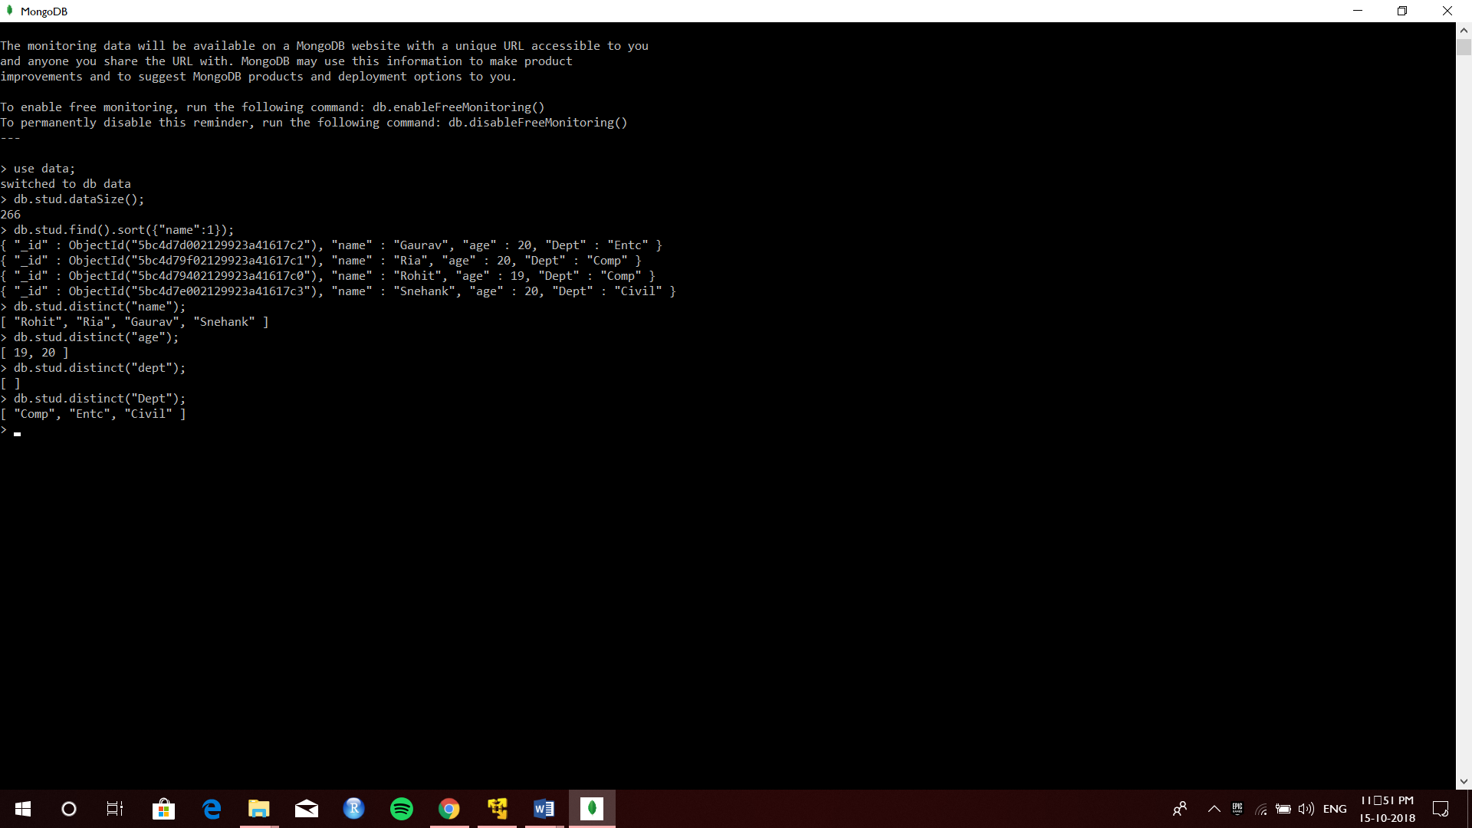

**Queries:**

Use data;

Db.stud.dataSize();

Db.stud.find().sort({“name” : 1});

Db.stud.distinct(“name”);

Db.stud.distinct(“age”);

Db.stud.distinct(“Dept”);

**Conclusion:** 5 queries were successfully implemented in MongoDB.